Name: Ahmed Basuony Abdelkader
ID: 2205124
The Report

-5G (2)
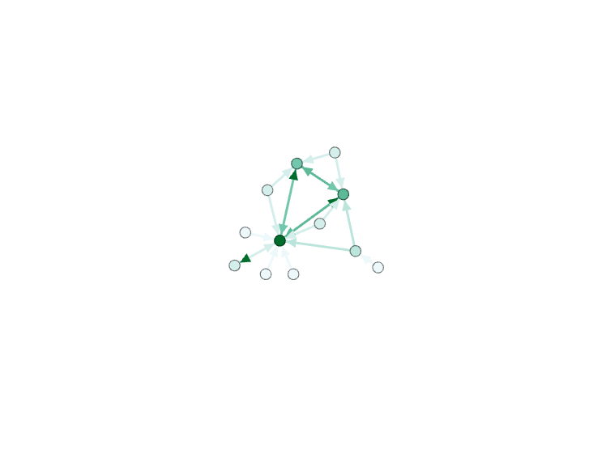Number of Nodes and Edges: 16 and 20
Avg. Degree: (20/16) *2=2.5
Graph Density:
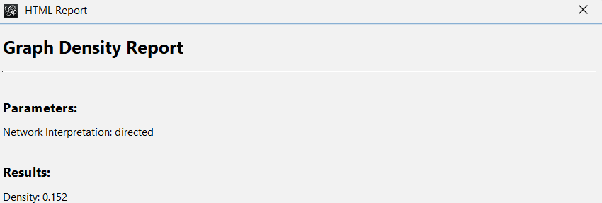

Avg. Clustering Coefficient:
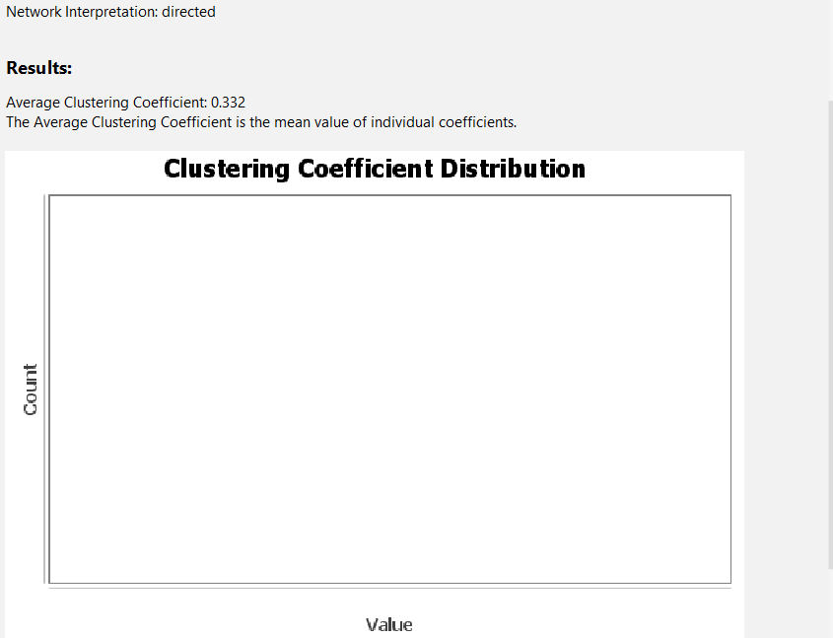

Modularity:
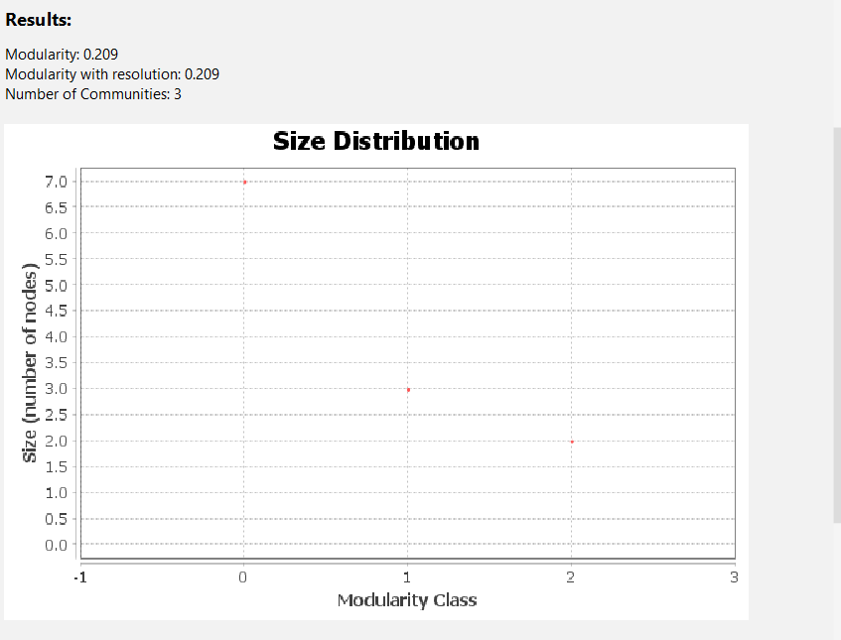

Centrality Measures:
-Betweenness Centrality:
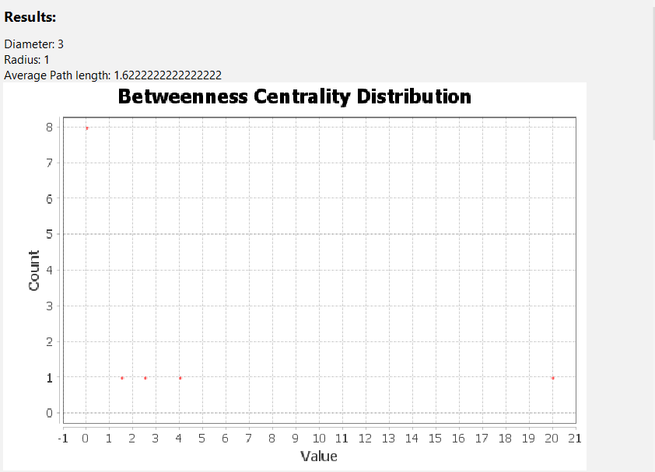
Closeness Centrality: -
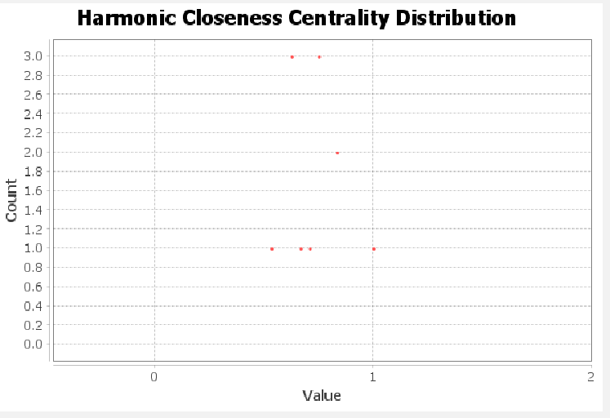

Connected Components:
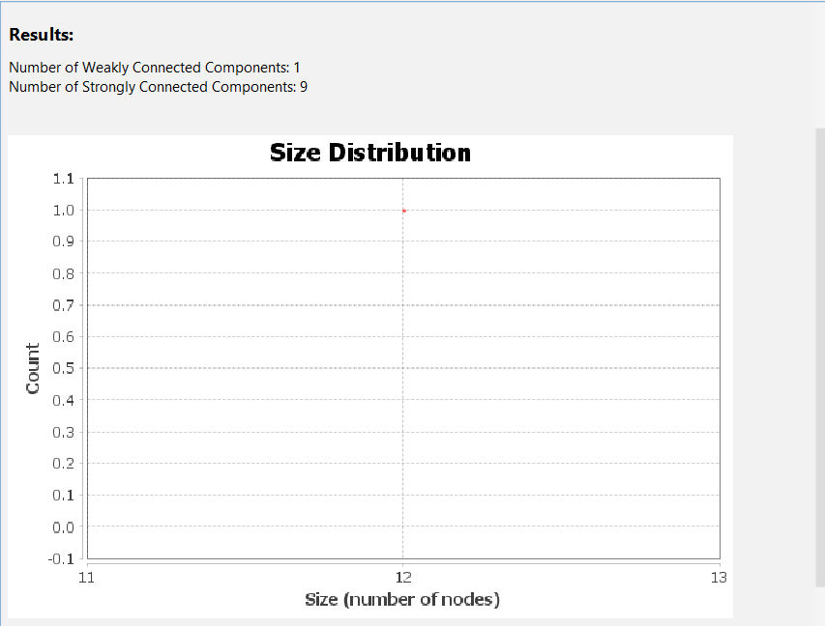
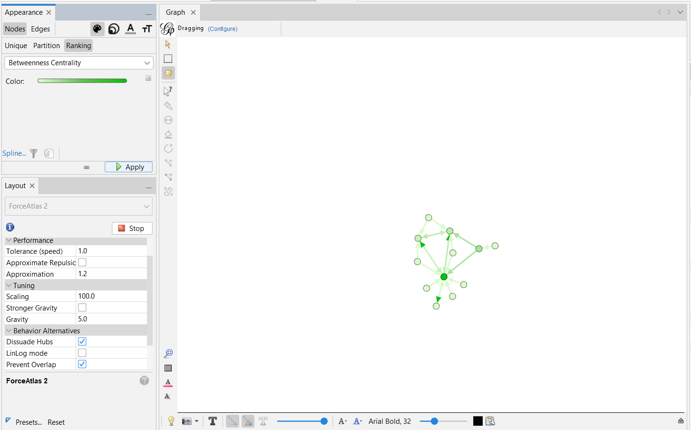

- Non_Conspiracy (3)
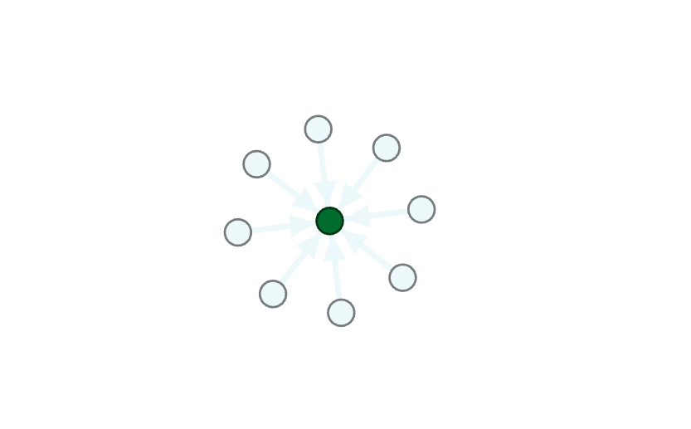-Number of nodes and edges: 9 and 8

Avg. Degree:

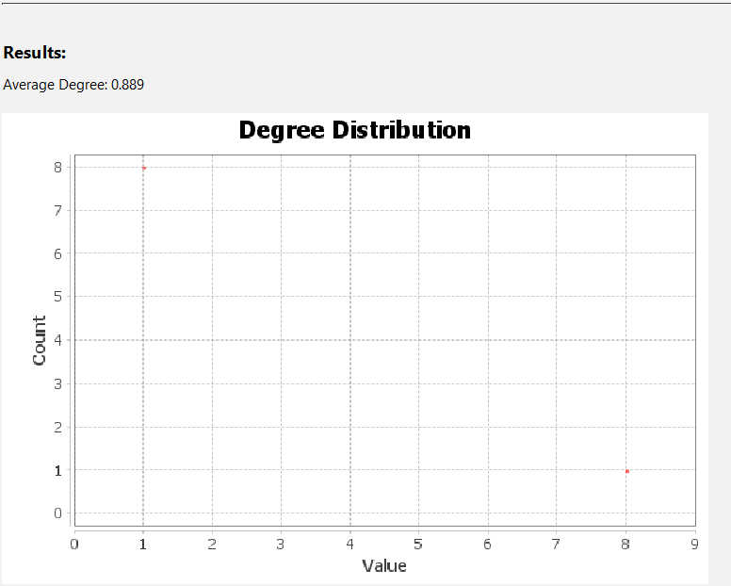
-Graph Density:
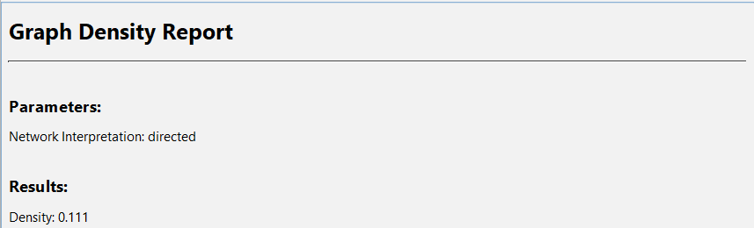

-Avg Clustering Coefficient:
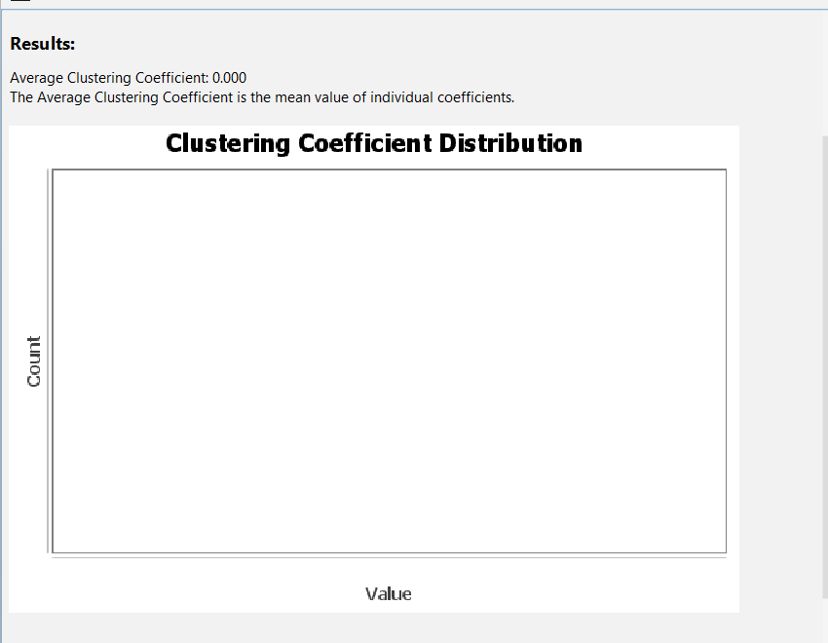

Modularity (Q) –
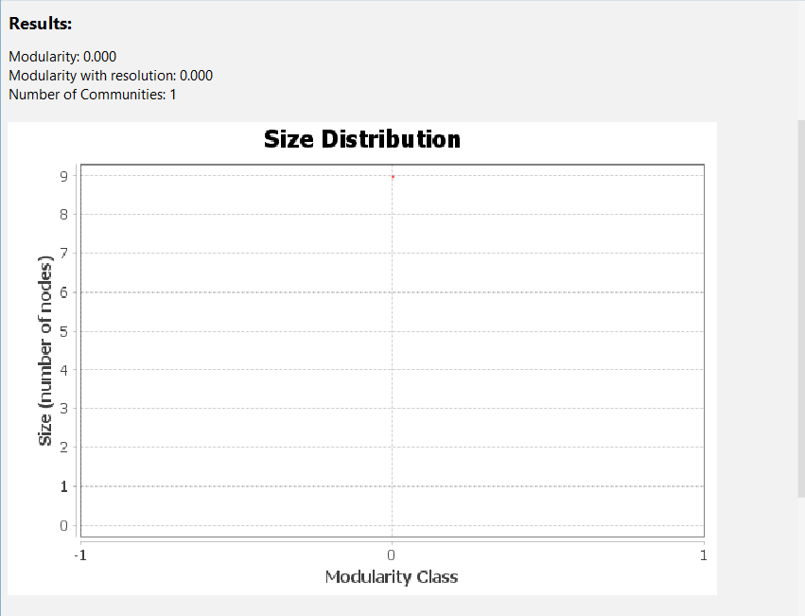

Betweenness and closeness centrality-
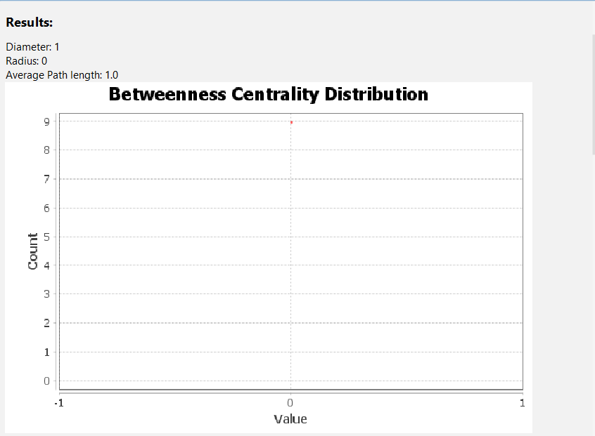
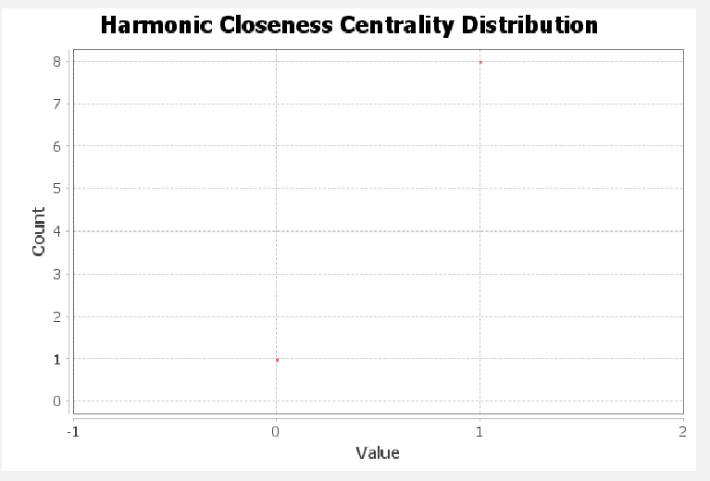

-Connected Components
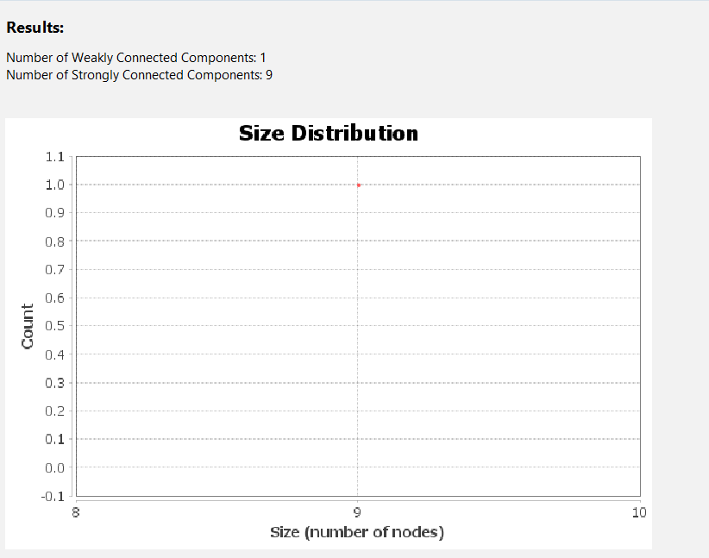

The Summary:
-The Basic Matrix:
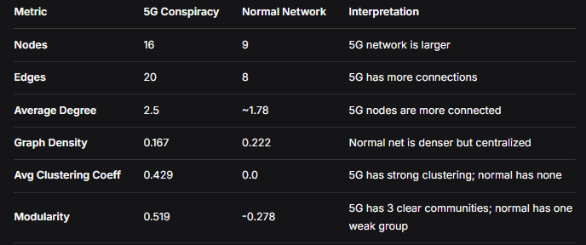

-Centrality & Connectivity
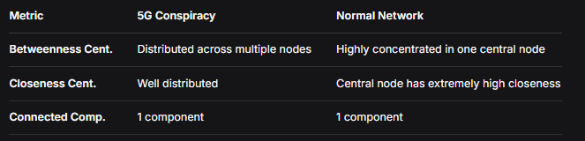
-Comparative Insights
